**Selenium Automation Script Documentation**

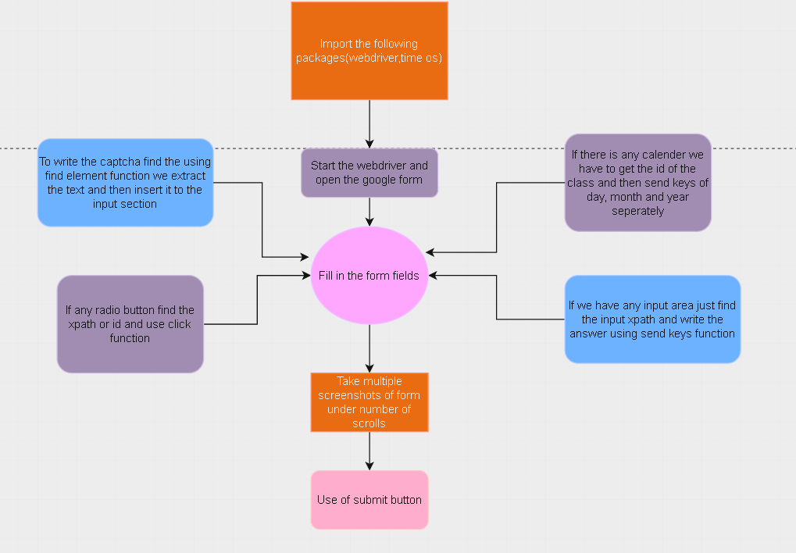

Workflow

**Overview**

This script automates the process of filling out a Google Form, capturing screenshots at various steps, and submitting the form using Selenium WebDriver in Python.

**Setup Instructions**

**Prerequisites**

* Latest Python installed on your system ([Download Python](https://www.python.org/downloads/))
* Chrome WebDriver installed if you are running on your local machine ([Download WebDriver](https://developer.chrome.com/docs/chromedriver/downloads))

### Dependencies Installation

Install the required Python libraries using pip:

Copy code:

**pip install selenium pillow**

### WebDriver Configuration

Ensure Chrome WebDriver is installed and accessible from your PATH environment variable.

**Usage**

1. **Clone the Repository**

Clone the repository containing the Selenium script.

cd Downloads

git clone https://github.com/Saptarshi2120/Selenium_Form

1. **Run the Script**

Execute the Python script :-

python Selenium_script.py

1. **Script Execution**

* The script will open the Google Form URL specified (https://forms.gle/WT68aV5UnPajeoSc8).
* It will fill out the form fields with predefined data (name, contact number, email, address, date, gender).
* Screenshots will be captured at each step and saved in the Downloads folder (~/Downloads).
* After capturing screenshots, it will fill in the CAPTCHA field automatically.
* Finally, the script will find the submit button and click it to submit the form.

**Customization**

* **Form Fields**: Modify the script (selenium_script.py) to change the data being filled in form fields.
* **XPath**: Adjust XPath expressions (//*[@id="..."]) in the script to match the structure of your specific Google Form.

**Troubleshooting**

* **WebDriver Issues**: Ensure Chrome WebDriver is up to date and compatible with your Chrome browser version.
* **Element Not Found**: Check and adjust XPath expressions if elements are not located correctly.